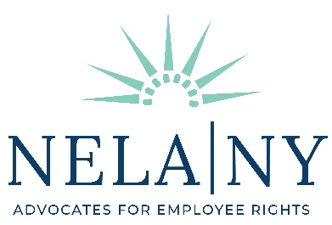

Spring Virtual Conference Agenda

6.5 Continuing Legal Education Credits

May 6, 2022

9:00 - 9:15 AM Opening Remarks/Welcome: Laurie Morrison, President

9:15 - 10:45 AM NY Legislative Law Updates (Areas of Professional Practice 1.5)

- William Cafaro, Partner, Law Offices of William Cafaro
- Miriam Clark, Partner, Ritz Clark Ben-Asher LLP
- Najah Farley, Senior Staff Attorney, National Employment Law Project
- Wayne Outten, Founder, Outten & Golden
- Marc Susswein, Founder, Law Office of Marc Susswein PC
- Kendall Onyendu, Associate, Outten & Golden (Moderator)

10:45 - 11:00 AM Break

11:00 - 12:00 PM Racism in the NFL (Diversity, Inclusion and Elimination of Bias 1)

- Michael Willemin, Partner, Wigdor LLP
- Lindy Korn, Founder, Law Office of Lindy Korn, PLLC (Moderator)

12:00 - 12:30 PM Lunch Break

12:30 - 1:30 PM Updates on Covid in the Workplace (Areas of Professional Practice 1)

- Ricky Blum, Staff Attorney, Legal Aid Society
- Cassandra Gomez, Staff Attorney, A Better Balance
- Raya Saksouk, Associate, Menken Simpson & Rozger LLP
- Amy Hong, Staff Attorney, Legal Aid Society (Moderator)

1:30 - 2:30 PM The Ethics of Advocating Against COVID Vaccine Mandates (Ethics and Professionalism 1)

- Michael Diederich, Jr., Founder, Diederich Law Office

2:30 – 2:45 PM Break

2:45 - 3:45 PM Recent Trends and Strategic Considerations for the Conditional Certification of Collective Actions under the FLSA (Areas of Professional Practice 1)

- John Troy, Founder, Troy Law PLLC
- Aaron Schweitzer, Managing Associate, Troy Law PLLC
- Tiffany Troy, Associate, Troy Law PLLC

3:45 - 4:45 PM Serving Transgender and Gender Non-Conforming Clients

(Areas of Professional Practice 1)

- Andy Izenson, Senior Associate Attorney, Diana Adams Law & Mediation, PLLC
- Laurie Morrison, Founder, Law Offices of Laurie E. Morrison
- Colleen Meenan, Partner, Meenan & Associates (Moderator)

4:45 PM Adjourn

